 Final Year Project - UG
School of Computing Science and Engineering (SCOPE)
B.Tech. CSE/CPS/AL AND ML Capstone Project IN HOUSE

General Report (Sept 2022 – November 2022)

Program: B.Tech. CSE Batch: 2019-2023 Course Code: CSE1904

Register No.: 19BCE1027 Name of the Student: Aryaman Mishra Mobile No.6390159999

Project Title:

Electric Vehicle Navigation with Parking System
General Report (Sept 2022 – November 2022)

Analyzed Literature Survey by scraping data of over 2000 papers and weighing Term Frequency and Inverse Document Frequency.
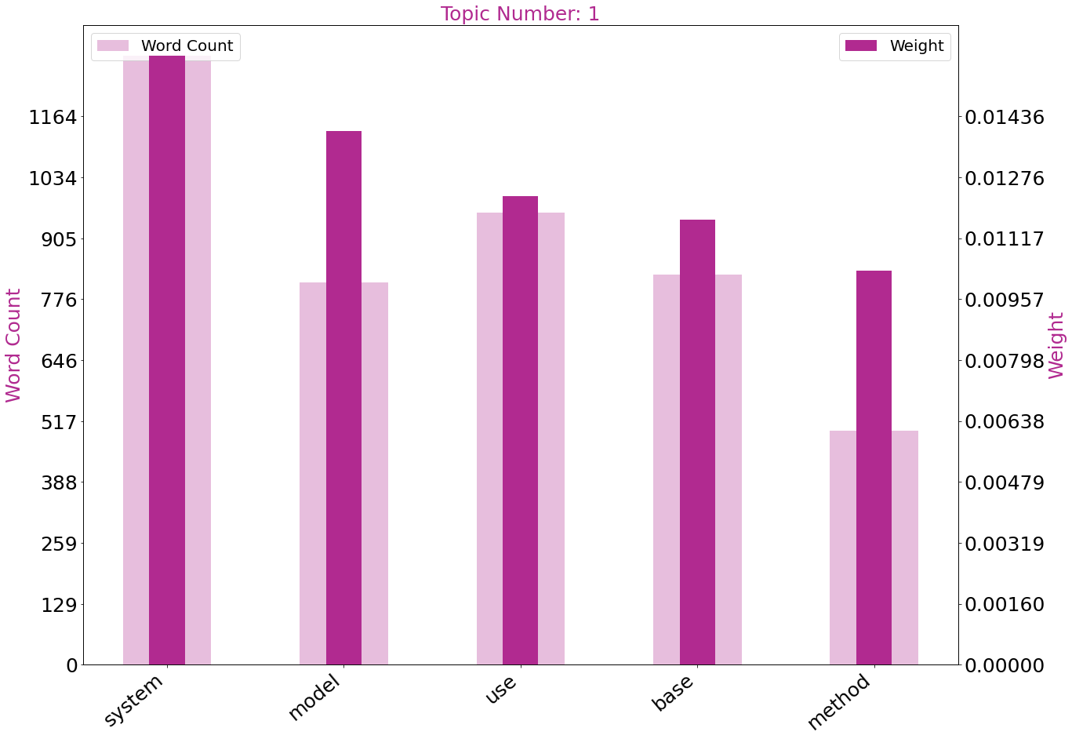
Visualized Survey data to make graphs for 6 keywords for the Capstone Project.
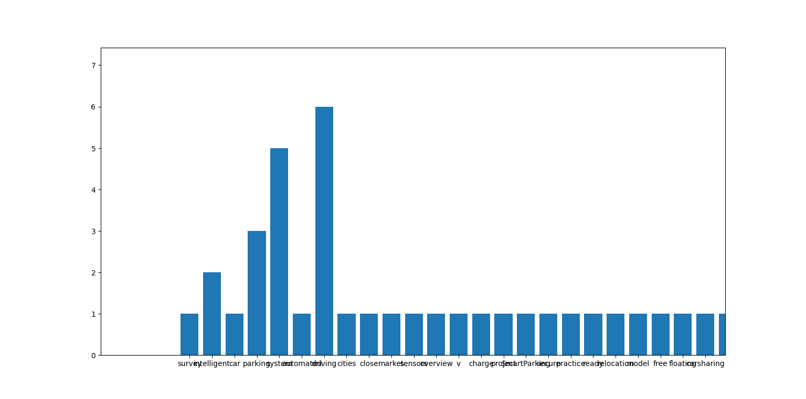
Created Parking System front-end.
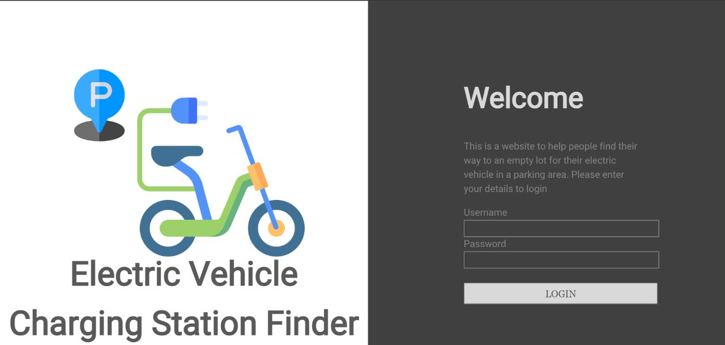

Implementation | Created Parking System front-end.Back-end Approaching Completion.
Work Status | Excellent / Good / Satisfactory / Needs improve
Attendance Status | Regular / Irregular | CAM – Max. 5 Marks per week

Signature of the Student with date Name & Signature of the Guide with date

